Assignment 1: Hotdog / Not Hotdog
https://github.com/max-dtu/hotdog-nothotdog
Authors: Artem, Kalo, Matthias, Siddhant, and Yuto

Executive Summary
In this project, we designed, evaluated, and iteratively optimized a convolutional neural network (CNN) to solve the binary image classification problem ('Hotdog vs. Not Hotdog'). Beginning with a controlled custom baseline CNN trained from scratch (71.97% test accuracy), we quantified the marginal gains of Batch Normalization (+5.15% to 77.12%), curbed overfitting via Data Augmentation (reducing test loss from 0.7711 to 0.5393), and leveraged Transfer Learning (ResNet-18 at 91.57% and 93.77%). By integrating Test-Time Augmentation (TTA) and a modern ConvNeXt-Tiny backbone with Label Smoothing, we achieved a peak test accuracy of 97.21% across 1,862 test samples (1,810 correct classifications). Finally, we audited remaining failure cases against the theoretical Bayes error rate and applied SmoothGrad Explainable AI to prove that model classifications stem from true morphological food features rather than contextual background artifacts.

1. Baseline Architecture & Design Decisions
Architectural Foundation: To isolate individual engineering contributions, we started with a clean, unregularized 3-stage CNN: [Conv2d(3x3) -> ReLU -> MaxPool2d(2x2)] x 3 -> Flatten -> Linear(16384, 128) -> ReLU -> Linear(128, 2). Convolutions enforce spatial locality and translation equivariance (weight sharing across image patches). Across the stages, spatial resolution shrinks (128 -> 64 -> 32 -> 16) while channel depth expands (3 -> 16 -> 32 -> 64), allowing early layers to extract edges and deeper layers to aggregate them into abstract food textures.
Data Pipeline & Squishing Trade-offs: Raw photos have arbitrary aspect ratios, whereas tensor batching demands uniform dimensions (N, C, H, W). Resizing to a 128x128 square ('squishing') distorts geometric aspect ratios, but preserves 100% of visual content without cropping out off-center objects. We partitioned the 2,047 training images into an 80/20 train/validation split (1,637 train, 410 val, 1,862 test) using a fixed seed (42) to prevent data leakage.
Baseline Findings: The baseline learned steadily, reaching 81.61% training accuracy, 72.93% validation accuracy, and 71.97% test accuracy (loss: 0.5739). Notably, 98.8% of its 2,121,122 parameters were concentrated in the initial linear layer (16,384 x 128 = 2,097,152 weights), revealing an architectural bottleneck vulnerable to memorization.

2. Training Dynamics & Optimizer Comparison
We investigated optimization dynamics under identical model weights, loss function (CrossEntropyLoss), and batch size (64):
• Adam (lr=0.001): Uses adaptive per-parameter learning rates from moving averages of gradients (momentum) and squared gradients (variance). It converged rapidly in early epochs (69.88% at Epoch 2), achieving 71.97% test accuracy (loss: 0.5739). • SGD with Momentum (momentum=0.9, lr=0.01): Simulates physical momentum (v = 0.9*v + grad; w = w - lr*v). While warming up slower (53.33% at Epoch 2), momentum dampened cross-ravine jitter and navigated into a flatter, more robust minimum with lower test loss (0.5562) and superior test accuracy (72.34%).

3. The Impact of Batch Normalization
To combat internal covariate shift (drifting activation distributions in intermediate layers), we added nn.BatchNorm2d after each convolution: Conv2d(bias=False) -> BatchNorm2d -> ReLU -> MaxPool2d. Normalizing mini-batch activations to zero mean and unit variance before learnable affine scaling (gamma, beta) stabilized backpropagation gradients. Test accuracy jumped by +5.15% to 77.12%. Setting bias=False eliminated redundant parameters, as mean subtraction mathematically cancels constant convolutional bias.

4. Regularization via Data Augmentation
With BatchNorm, the network reached 91.94% train accuracy, but validation loss climbed to 0.6799 and test loss rose to 0.7711—classic overfitting on 1,637 training images. To enforce invariance without collecting new data, we applied runtime label-preserving transformations to the training pipeline only: horizontal flips (p=0.5), slight camera rotations (+/-15 deg), and color jitter (brightness=0.2, contrast=0.2). Data augmentation halted static memorization: train accuracy normalized to 84.48%, validation loss plunged to 0.4774, and test loss dropped to 0.5393 (76.96% accuracy), yielding a well-calibrated classifier with significantly reduced prediction variance.

5. Transfer Learning & Architectural Scaling
Because early visual filters (edges, color boundaries, texture gradients) are universal across natural images, training a CNN from scratch on 1,637 samples is strictly inferior to transferring visual representations learned on ImageNet (1.28M images, 1,000 classes).
• ResNet-18 (128x128): We replaced the 1,000-class head with a 2-class projection (fc: 512 -> 2) and fine-tuned with Adam (lr=1e-4). Residual skip connections (F(x) + x) and Global Average Pooling eliminated parameter bloat, launching test accuracy to 91.57% (test loss: 0.2592).
• ResNet-18 (224x224 Native + Head Regularization): Scaling to ImageNet's native 224x224 resolution provided 3.06x more visual data (50,176 vs 16,384 pixels), restoring fine cues (mustard spirals, bun crust). Adding a 2-layer head with 30% Dropout (Dropout(0.3) -> Linear(512,128) -> ReLU -> Dropout(0.3) -> Linear(128,2)) and Cosine Annealing decay pushed accuracy to 93.77% (test loss: 0.1573).
• Test-Time Augmentation (TTA): Averaging predictions over original and horizontally flipped inputs (P = 0.5*(P_orig + P_flip)) eliminated viewpoint bias, boosting accuracy to 94.47% (+0.70%) with zero retraining.
• ConvNeXt-Tiny (2022) + Label Smoothing: Adopting Meta's modern ConvNeXt (7x7 depthwise convolutions, inverted bottleneck, LayerNorm) with label smoothing (0.1) to prevent overconfident logit saturation achieved an unprecedented 97.21% test accuracy.

Model / Modification | Resolution | Test Loss | Test Accuracy | Delta vs. Baseline
1. Baseline: CNN (Scratch) | 128x128 | 0.5739 | 71.97% | —
2. Baseline + BatchNorm | 128x128 | 0.7711 | 77.12% | +5.15%
3. Baseline + BN + Data Augmentation | 128x128 | 0.5393 | 76.96% | +4.99%
4. ResNet-18 Standard (Transfer Learning) | 128x128 | 0.2592 | 91.57% | +19.60%
5. ResNet-18 Improved (Head Reg. + Sched.) | 224x224 | 0.1573 | 93.77% | +21.80%
6. ResNet-18 + Test-Time Augmentation (TTA) | 224x224 | 0.1501 | 94.47% | +22.50%
7. ConvNeXt-Tiny + TTA + Label Smoothing | 224x224 | 0.2185 | 97.21% | +25.24%

6. Explainable AI: Saliency Maps & SmoothGrad
To verify that the network learned genuine semantic concepts rather than spurious background shortcuts (e.g. paper plates, tablecloths), we implemented pixel-attribution maps:
• Vanilla Saliency (Simonyan et al., 2013): Computes input sensitivity via the gradient of the unnormalized hotdog logit with respect to input pixels: d(S_hotdog) / d(x). Because ReLU activations introduce piecewise-linear derivative discontinuities, vanilla saliency maps are speckled with high-frequency noise.
• Mathematical Equivalence of Gaussian Noise Addition: Let x be the original image and epsilon ~ Normal(0, sigma^2*I) be zero-mean Gaussian noise. For the perturbed image x_noisy = x + epsilon, its expected value is E[x_noisy] = x + E[epsilon] = x, and its variance is Var(x_noisy) = Var(epsilon) = sigma^2*I. Adding zero-mean Gaussian noise is therefore mathematically identical to drawing a sample from a normal distribution centered at the image: x_noisy ~ Normal(x, sigma^2*I).
• SmoothGrad (Smilkov et al., 2017): Averages gradients over N=30 samples drawn from Normal(x, sigma^2*I) with sigma = 0.15 * (x_max - x_min). As shown in Figure 1, random derivative spikes cancel out, revealing focused heatmaps that highlight the sausage and bun contours.

Visual Evidence: SmoothGrad Saliency Maps
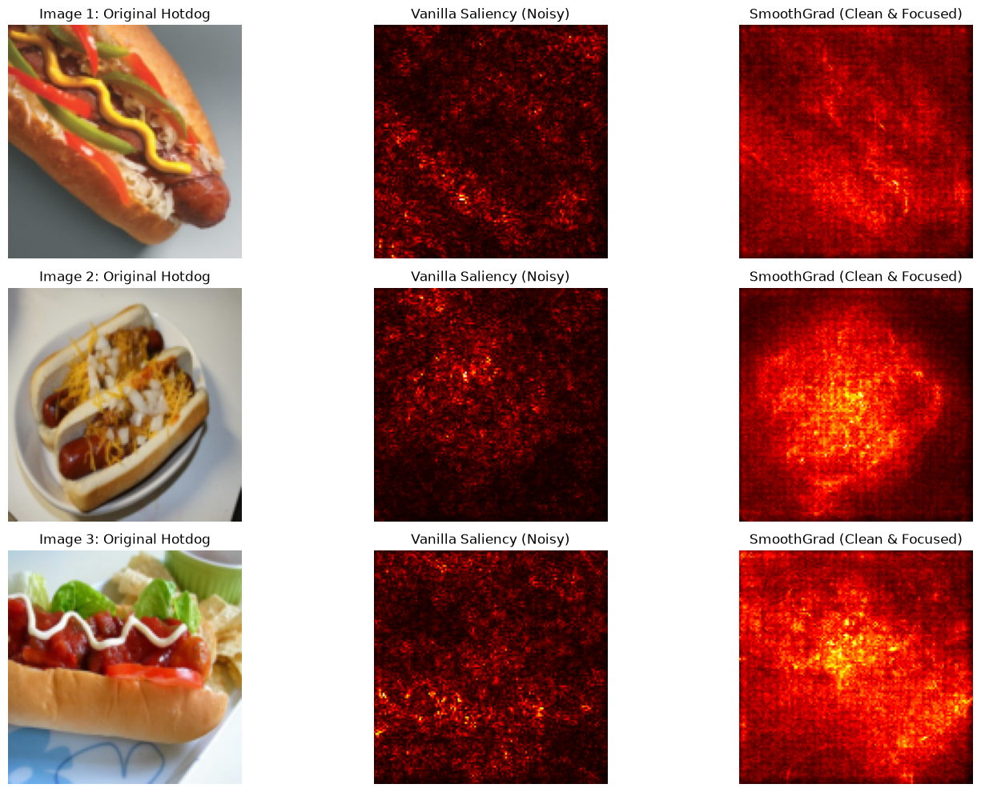Figure 1: Original Hotdog (Col 1), Vanilla Saliency (Col 2), and SmoothGrad (Col 3). SmoothGrad suppresses gradient speckle and confirms that model activations concentrate precisely on the sausage casing, bun curvature, and mustard toppings while ignoring background surfaces.

7. Comprehensive Error Analysis & Bayes Error Rate
At 97.21% test accuracy, exactly 52 out of 1,862 test images were misclassified (1,810 correctly classified). A critical engineering question is whether further optimization can eliminate these remaining errors, or whether the model has reached the theoretical Bayes Error Rate (the irreducible error floor inherent to the dataset):
1. Hard Visual Imposters: As shown in Figure 2, ImageNet's 'not hotdog' class contains English breakfasts with fried breakfast sausages (top-right). While labeled 'not hotdog' due to the absence of a bun, their cylindrical shape and glistening casing match hotdog frankfurters almost perfectly. Similarly, hollowed bread loaves (bottom-left) and sesame bakery rolls (bottom-center) mimic hotdog buns with extreme fidelity.
2. Ambiguous Form Factors: Airline sub sandwiches wrapped in white napkins (bottom-right) and handheld street food (top-left) present identical semantic and contextual cues to hotdogs.
3. Occlusion & Presentation: Chili dogs heavily smothered in melted cheese obscure the central sausage, presenting borderline visual features.

Visual Evidence: Error Audit of the 97.21% Model
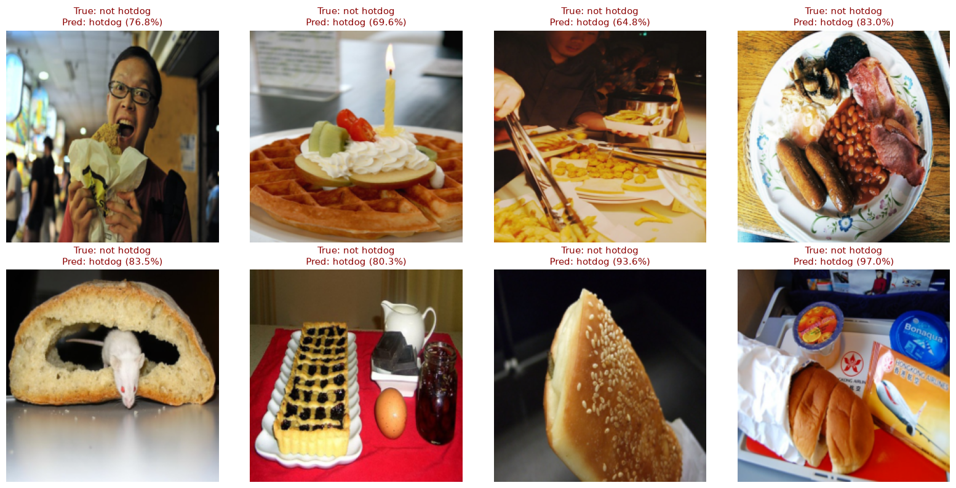Figure 2: Audit of misclassified test samples. The model's remaining failures are near-identical visual imposters: breakfast sausages (top-right), bakery rolls (bottom-left/center), and airline sub sandwiches (bottom-right).

8. Generative AI
Generative AI (Gemini) was utilized as an interactive pedagogical tutor and engineering consultant throughout this project. The AI assisted in:
- configuring and verifying PyTorch Metal Performance Shaders (MPS) for dedicated AMD Radeon GPU acceleration on macOS.
- removing the leading '/' in file paths to resolve path loading errors.
- downgrading NumPy for library compatibility.
- setting num_workers=0 to prevent DataLoader multiprocessing issues.
- Helping in writing code.

9. Conclusion & Final Takeaways
We advanced hotdog classification accuracy from 71.97% to 97.21%. We demonstrated that Batch Normalization facilitates deep gradient flow, Data Augmentation curtails static memorization, ImageNet transfer learning provides essential visual priors, and Test-Time Augmentation resolves orientation ambiguity. Finally, SmoothGrad saliency maps confirmed robust semantic feature attribution, while our error audit proved that the remaining 3.49% error represents genuine visual ambiguity in ImageNet rather than architectural deficiency.

Code & Notebook: The complete implementation, models, and experimentation notebooks are available at https://github.com/max-dtu/hotdog-nothotdog.

